# Tizen Debugging and Testing Tools

## Required Software and Documentation

It is required to have Tizen SDK installed to use Tizen tools. Emulator, Simulator and Emulator Manager applications comes with Tizen SDK.

The Tizen Web Simulator runs on the Google Chrome browser. To use the Tizen Web Simulator you must first download and install Google Chrome on your development platform: http://www.google.com/chrome/

All Tizen specific documentation for these tools available on Tizen web site in Dev Guide document section [Running and Debugging Applications](http://developer.tizen.org/help/topic/org.tizen.web.appprogramming/running_debugging.htm).

## Important concepts

All Tizen application developed with Titanium really are Web Applications(widgets)

Developer may run widget in one of the following environments:

* **Simulator** - The Tizen Web simulator allows you to run widgets that use the Tizen Web APIs.
* **Emulator** - The device Emulator, provided with the Tizen SDK, imitates the target environment running Tizen Web applications. Using this replicated environment, you can test your widget before deploying it to the real target device.
* **Target Device** - Running your widget on a target device allows you to debug and test your widget in a real-time environment.

## Emulator

## Target Device

**Launch your application in the Simulator**

Open Tizen Web Simulator via application menu (in Windows).

<file:///C:/projects/appceleraror/gtt/repo_titanium_tizen/titanium_mobile_tizen/tests/samples/KitchenSink/build/tizen/index.html>

KitchenSink application in the simulator

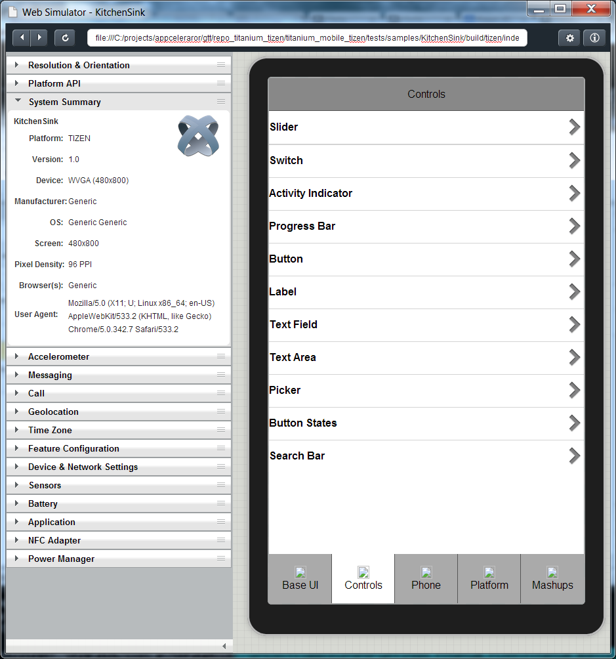

## Using Tizen IDE to Debug Titanium Applications

It is possible to install, run and debug Titanium application with Tizen IDE (available as part of Tizen SDK). It may make sense if developer needs some features not available from Titanium CLI. E.g. It allow us use event inspector

## Debugging a Widget

Developers can debug a widget by debugging its JavaScript code while running it in the target. JavaScript debugging uses the Remote Inspector connected with the WebKit on the target.

To debug widget use web-debug command from SDK availale at <TIZEN_SDK>\tools\ide\bin\

web-debug.bat -w "path to wgt" -id <ID>

On successful application start it shows debug URL in console, e.g.:

DEBUG URL : http://localhost:57283/inspector.html?page=1

Open this URL to get access to Remote Inspector used to debug the application.

CAUTION: Remote Inspector doesn't support multiple debugging.

CAUTION: avoid use spaces in application path and wgt file name. It does not works on Beta version available now.